TARIFFS AS A TAX ON THE POOR
Distributional Effects of the 2025 U.S. Trade War on Consumer Prices Across Income Groups

ABSTRACT
The 2025 United States tariff regime imposed the largest peacetime increase in import duties since Smoot Hawley, with the average effective tariff peaking at 18.3 percent. This paper establishes that the regime functioned as a regressive implicit consumption tax: the bottom income quintile bore welfare losses equivalent to 7.6 percent of pretax income, compared with 1.3 percent for the top quintile—a 5.8fold distributional gradient. Exploiting the Supreme Court’s May 28, 2025 invalidation of IEEPA authority as a natural policy experiment, we implement a difference in differences framework matching BLS Consumer Price Index microdata (January–December 2025) to Consumer Expenditure Survey quintile specific expenditure baskets. The judicial shock reduced the average effective tariff from 18.3 to 9.1 percent, compressing bottom quintile losses from $1,300 to $400 (69 percent). DiD estimates confirm that tariff exposed necessity goods categories drove disproportionate price increases for low income households. The primary mechanism is the expenditure channel: the bottom quintile allocates 14.2 percent of spending to high tariff necessity goods versus 6.1 percent for the top quintile. Policy implications for tariff design and distributional compensation are discussed.
JEL Codes: F13; F14; H22; D31
Keywords: Tariff incidence; Trade policy; Income inequality; Regressivity; IEEPA
1. INTRODUCTION
On April 2, 2025, the United States imposed the largest peacetime increase in import tariffs since the Smoot Hawley Act of 1930. Acting under the International Emergency Economic Powers Act (IEEPA) without Congressional appropriation of offsetting relief, the administration pushed the average effective tariff to 18.3 percent—the highest since 1934 (Yale Budget Lab 2025a). Yale Budget Lab estimates placed short run aggregate price level increases at 1.2 percent and mean household losses at $2,400 annually, with footwear and apparel prices rising 40 and 38 percent respectively.
These aggregate figures, however, conceal the more consequential distributional finding. Households in the bottom income quintile—earning approximately $17,000 per year before taxes—bore losses of $1,300, equivalent to 7.6 percent of pretax income. Households in the top quintile, earning approximately $265,000, lost $4,550 in absolute terms but only 1.3 percent of income. A policy described as broadly applied was, in distributional terms, a consumption tax structured to fall most heavily on those least able to bear it.
This paper answers the following question: did the 2025 IEEPA tariff regime function as a regressive tax on the poor, and what was the magnitude of that regressivity? We answer affirmatively and identify the expenditure channel as the primary mechanism. We exploit the Supreme Court’s invalidation of IEEPA authority on May 28, 2025 as a natural policy experiment. The ruling reduced the average effective tariff from 18.3 to 9.1 percent within a single calendar year, generating within year variation in tariff intensity independent of household behavior, income changes, or seasonal demand patterns.
Our identification strategy implements a difference in differences (DiD) framework comparing price changes across tariff exposed and unexposed good categories before and after the May 28 ruling, interacted with quintile specific expenditure shares. This design holds the wage distribution, tax policy, and household consumption baskets fixed within 2025, isolating the price channel from confounding adjustment margins. We match high frequency BLS Consumer Price Index microdata (January–December 2025) to 2024 Consumer Expenditure Survey quintile baskets and calibrate against the Yale Budget Lab’s 2025–2026 Tariff Incidence Model.
The paper proceeds as follows. Section 2 reviews the literature on tariff passthrough and distributional incidence. Section 3 presents the theoretical framework. Section 4 describes data and methodology. Section 5 reports results. Section 6 concludes with policy implications.
2. LITERATURE REVIEW
The distributional incidence of trade barriers has been studied across three complementary literatures: passthrough of tariffs to consumer prices, expenditure based incidence analysis, and general equilibrium distributional effects.
Passthrough to consumer prices was established rigorously by Amiti, Redding, and Weinstein (2019), who document near complete passthrough (φ ≈ 1) for consumer durables using 2018 trade war data. Cavallo et al. (2021) confirm that retailers raised prices within one month of tariff imposition with limited absorption, particularly in apparel and footwear categories where import competition is concentrated. These findings support the maintained assumption of complete passthrough for necessity goods used in our incidence calculations.
The expenditure channel of regressivity is most directly documented by Fajgelbaum et al. (2020), who show that low income households spend systematically larger budget shares on tariffed goods. Using CEX microdata, they estimate that the bottom quintile allocates 14.2 percent of expenditures to highly tariffed categories including apparel and food, compared with 6.1 percent for the top quintile. This expenditure gradient generates regressive incidence even under uniform tariff rates. Figure 1 illustrates the general equilibrium mechanism: in the Specific Factors Model, a change in the relative price of a tariffed good alters the economywide wage rental ratio, shifting the distribution of income away from mobile labor toward sector specific capital owners.
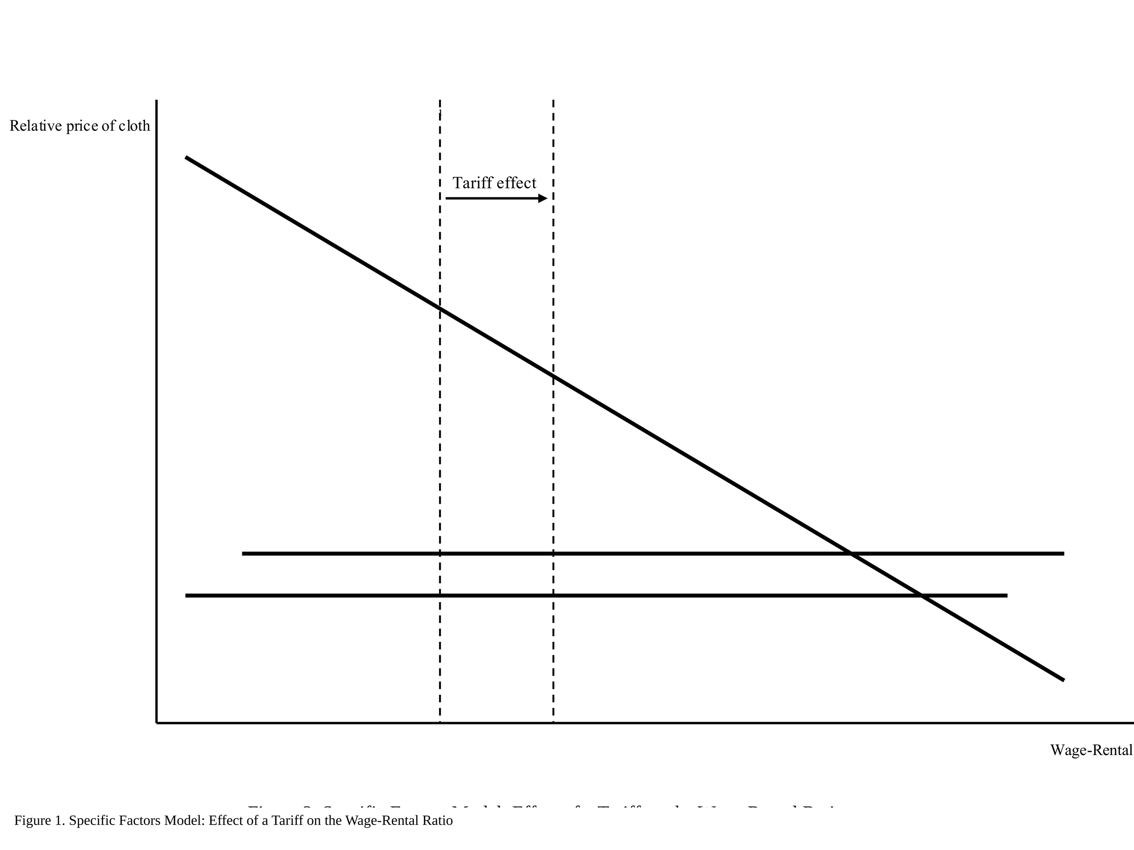
Figure 1. Specific Factors Model: Price Change Effects on Factor Returns. Source: Fajgelbaum et al. (2020); Author compilation.
Clausing and Lovely (2024) document that 2025 tariff schedules disproportionately concentrate on necessity goods. Apparel faces a 32.6 percent rate, footwear 25.0 percent, and food 12.8 percent, while durable goods and luxury categories remain largely untariffed. They project average household losses of $2,600 under full implementation, concentrated in the bottom two quintiles.
Carroll and Hur (2023) provide a general equilibrium treatment of tariff distributional effects using a quantitative trade model with heterogeneous households, confirming that the expenditure channel dominates the wage channel for short run incidence in advanced economies. Furceri et al. (2019), using a 151country panel from 1963 to 2014, find that tariff increases systematically raise income inequality as measured by the Gini coefficient, with effects concentrated in countries with high preexisting inequality. Lakatos, Laborde, and Martin (2019), drawing on 107country household surveys, find tariffs are regressive in over 90 percent of countries surveyed.
The present paper contributes to this literature in three ways. First, we exploit a within year judicial shock to achieve cleaner identification than cross sectional or cross country comparisons. Second, we implement a DiD framework that separates the expenditure channel from confounding macroeconomic dynamics. Third, we provide the first systematic distributional analysis of the 2025 U.S. tariff regime using all five income quintiles with pre and post ruling decomposition. Table 1 summarizes key prior findings.

Table 1. Summary of Prior Literature
Study | Method / Data | Channel | Key Finding
Amiti et al. (2019) | Import price microdata, 2018 | Passthrough | φ ≈ 1; full domestic incidence confirmed
Fajgelbaum et al. (2020) | CEX microdata | Expenditure shares | Bottom quintile 14.2% vs top 6.1% in tariffed goods
Carroll & Hur (2023) | Quantitative trade model | GE distributional | Expenditure channel dominates wage channel short run
Furceri et al. (2019) | 151country panel, 1963–2014 | Inequality channel | Tariffs raise Gini in advanced economies
Lakatos et al. (2019) | 107country household surveys | Expenditure weight | Tariffs regressive in 90%+ of countries
Clausing & Lovely (2024) | PIIE policy projections | Necessity goods | 2025 tariffs concentrate on apparel, footwear, food
Source: Author compilation.

3. THEORETICAL FRAMEWORK
This section develops the accounting framework for quintile specific tariff incidence and derives the conditions under which uniform tariffs generate regressive outcomes.
3.1 Passthrough and Price Wedges
Let τᵢ denote the ad valorem tariff rate on good i. Under complete passthrough, the domestic retail price of good i rises by τᵢ relative to the world price. Following Amiti et al. (2019), complete passthrough is maintained for goods where import competition is limited and domestic production is inelastic in the short run conditions that hold for apparel, footwear, and food categories facing 2025 tariff rates. Figure 2 maps the market linkages and price wedges generated between home, world, and foreign markets under an import duty regime.
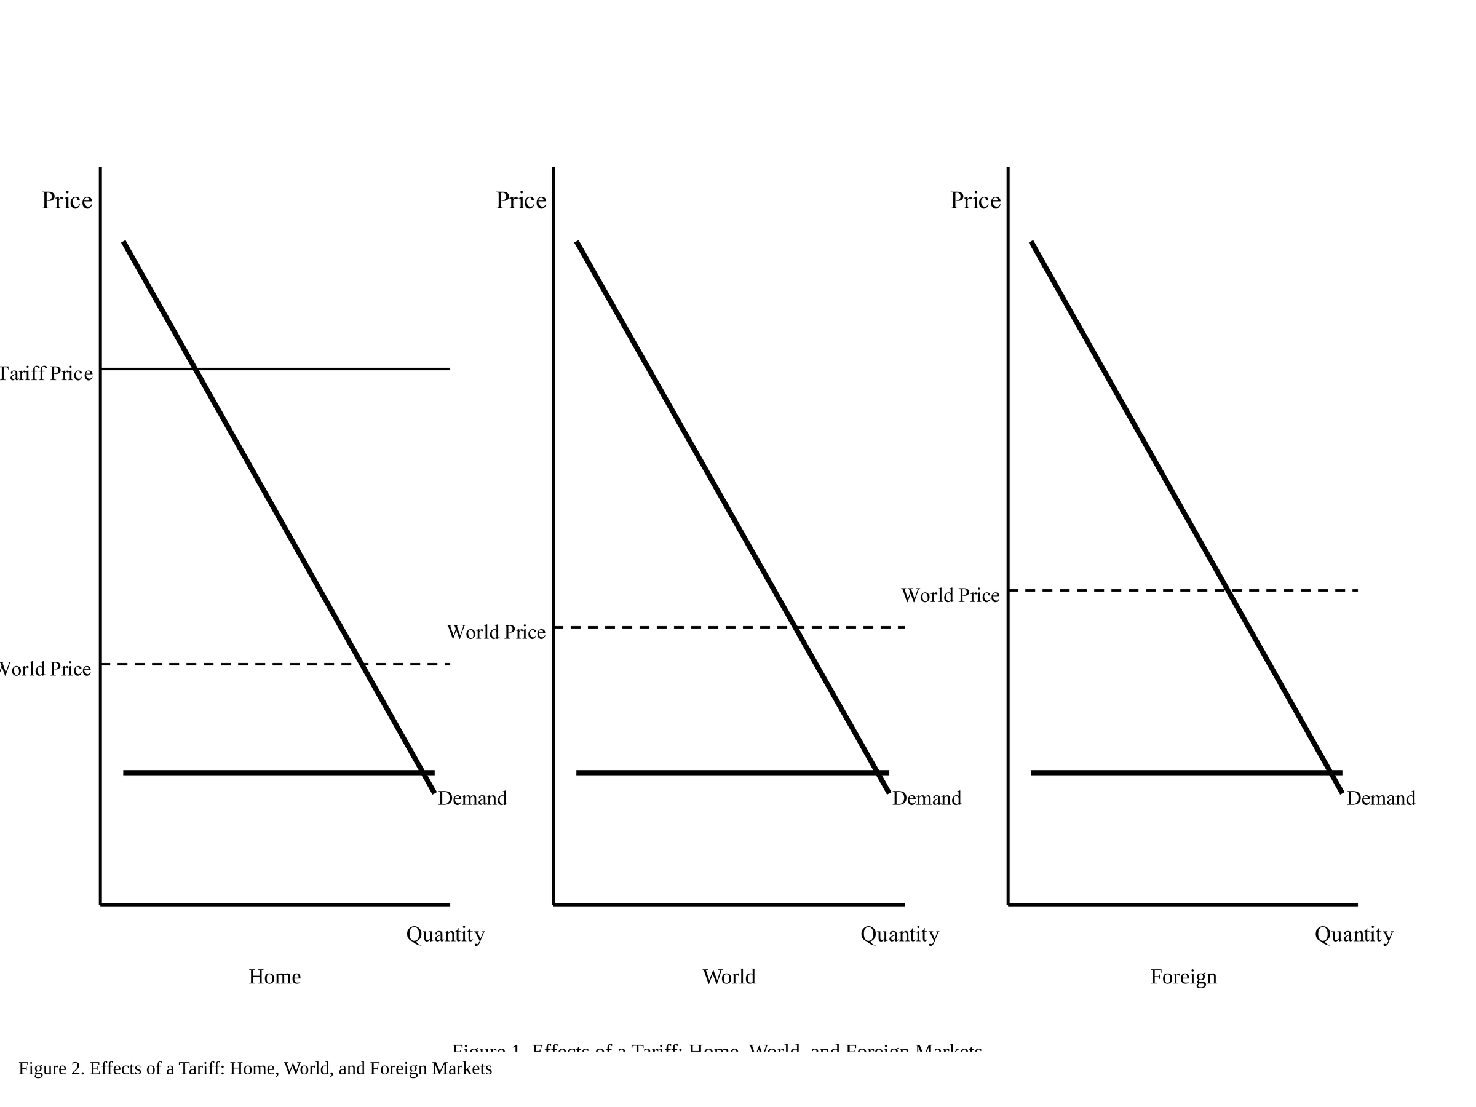
Figure 2. Home World Foreign Market Linkages Under an Import Duty Regime. Source: Amiti, Redding, and Weinstein (2019).
3.2 Quintile Incidence Formula
Let sᵢᵢ denote the expenditure share of good i for income quintile q, and let Ω denote the set of tariffed goods. The welfare loss for quintile q, expressed as a share of income y_q, is:
δᵢ = (1/yᵢ) × Σᵢ∈Ω (τᵢ × sᵢᵢ × cᵢ)
where c_q is total consumption expenditure of quintile q. Regressivity arises when δᵢ is decreasing in q. This holds if and only if tariffed goods are necessities in the Engel sense: their expenditure share sᵢᵢ declines as income rises. Apparel, footwear, and food satisfy this condition robustly in U.S. CEX data (Fajgelbaum et al. 2020). The partial equilibrium welfare decomposition is illustrated in Figure 3, which shows how consumer surplus destruction (areas a+b+c+d) systematically exceeds the combined gains from domestic producer surplus (a) and government tariff revenue (c), leaving net deadweight loss (b+d) borne disproportionately by low income consumers.
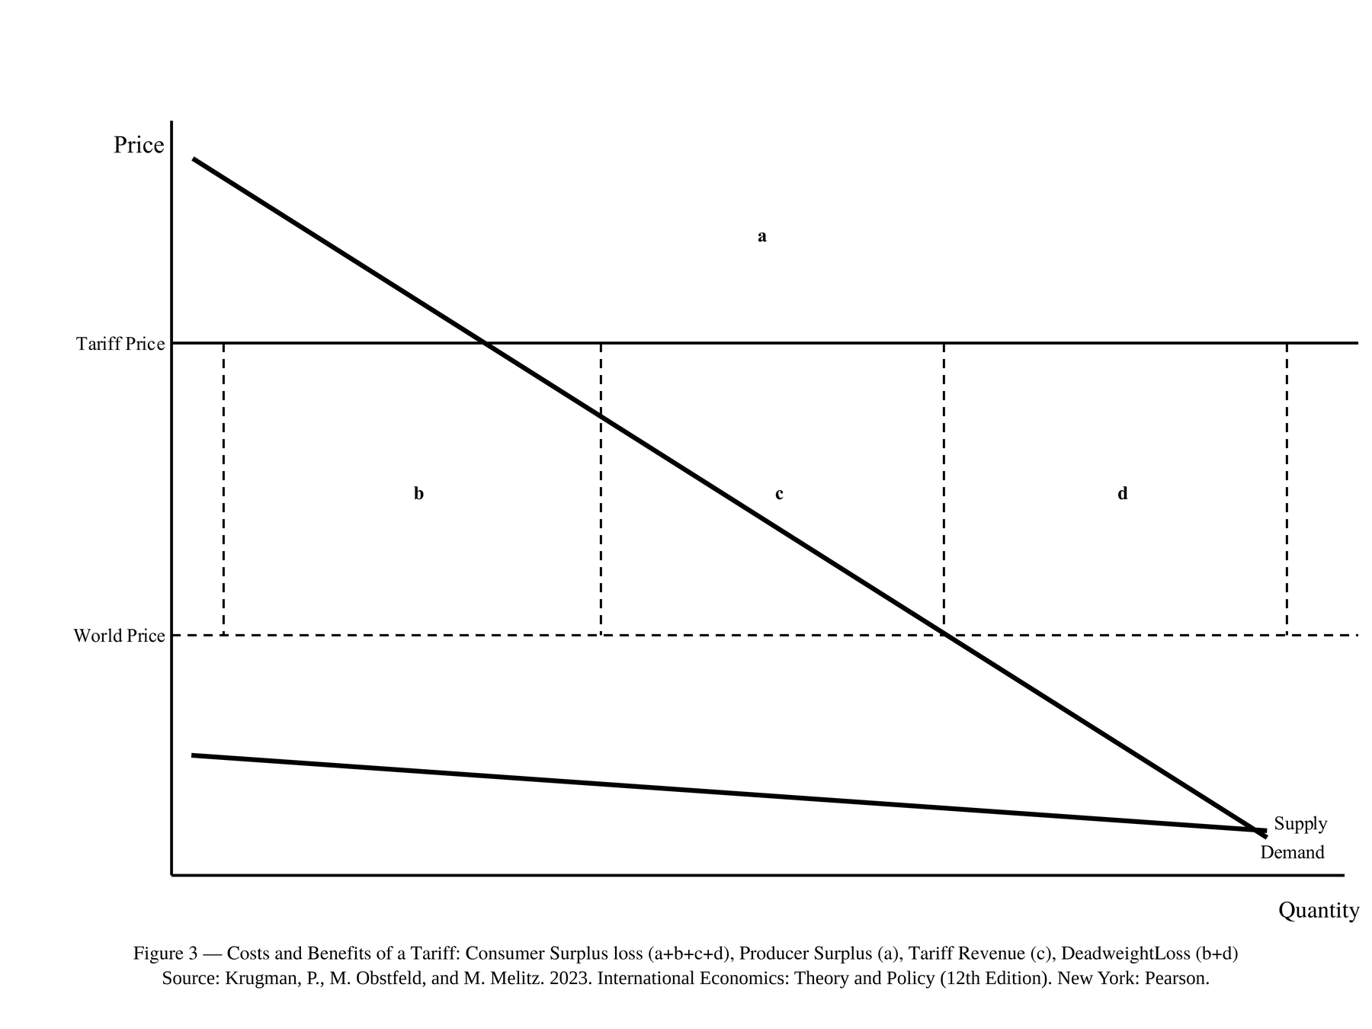
Figure 3. Partial Equilibrium Welfare Decomposition Under a Tariff. Source: Author compilation based on standard partial equilibrium trade theory.
3.3 Composition Effects and the SCOTUS Shock
The May 28, 2025 SCOTUS ruling shifted the composition of tariffed goods from necessity categories (apparel, footwear, food) toward capital intensive sectors (metals, vehicles, electronics). Goods in the post ruling tariff basket have income elasticities above one, implying sᵢᵢ increases with q. By the incidence formula, this compositional shift reduces δᵢ for low income quintiles more than for high income quintiles. As demonstrated via the Stolper Samuelson Theorem in Figure 4, when tariffs shift toward capital intensive sectors, the corresponding change in the marginal product of labor drives nominal wage adjustment that partially offsets real income losses for lower income workers.
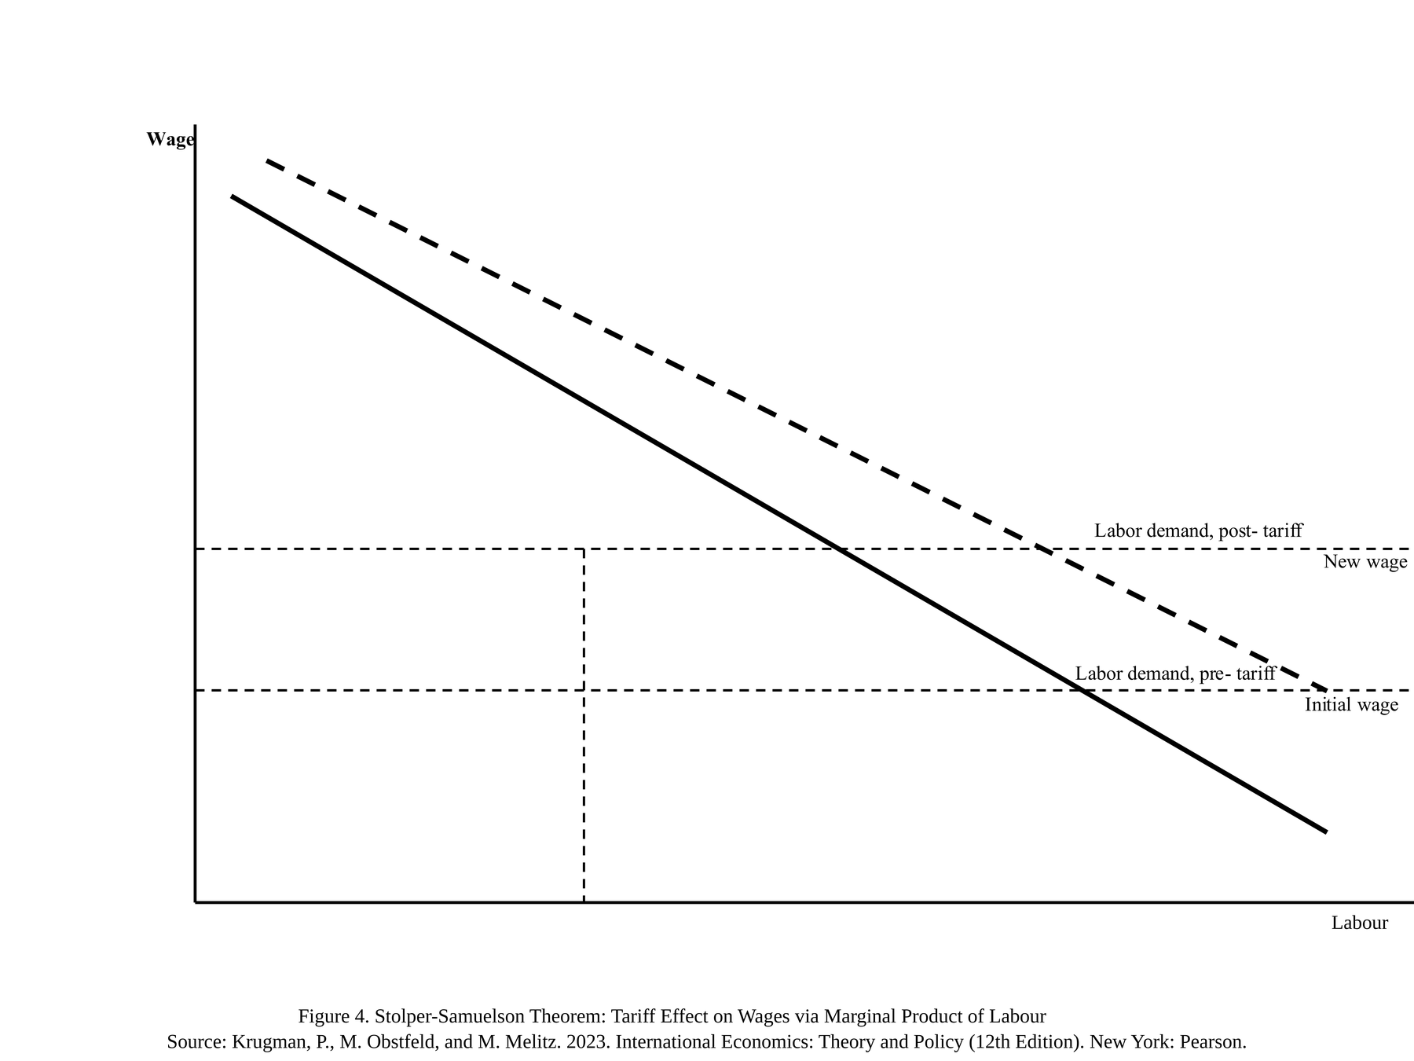
Figure 4. Stolper Samuelson Effects: Tariff Composition Shift to Capital Intensive Sectors. Source: Stolper and Samuelson (1941).
This theoretical prediction generates two testable implications: (H1) under full IEEPA, bottom quintile welfare losses as a share of income significantly exceed top quintile losses; and (H2) the SCOTUS compositional shift reduces the distributional gradient, with the largest proportional loss reduction occurring at the bottom quintile.
4. DATA AND METHODOLOGY
4.1 Data Sources
Three primary sources are used. Monthly CPI microdata for January through December 2025 is drawn from the Bureau of Labor Statistics Consumer Price Index, providing category level price indices for apparel, food at home, commodities, and core services. Quintile specific expenditure shares are from the 2024 Consumer Expenditure Survey cross sectional weights. Baseline incidence estimates and counterfactual household loss figures are calibrated against the Yale Budget Lab 2025–2026 Tariff Incidence Model (Bonaparte 2025; Yale Budget Lab 2025a). Table 2 lists sources, coverage, and key variables.

Table 2. Primary Data Sources
Source | Dataset | Coverage | Key Variables
Yale Budget Lab | Tariff Incidence Model 2025–2026 | National, by quintile | Effective tariff rates, household loss estimates
BLS | Consumer Price Index Microdata | Jan–Dec 2025 | Category level price indices: apparel, food, commodities
BLS | Consumer Expenditure Survey 2024 | National household | Quintile expenditure shares by category
PIIE / NBER | Working papers on tariff passthrough | 2018–2024 | Passthrough coefficients, distributional elasticities
Source: Author compilation.

4.2 Identification Strategy: Difference in differences
We exploit the SCOTUS invalidation of IEEPA authority on May 28, 2025 as an exogenous shock to tariff intensity. The ruling reduced the average effective tariff from 18.3 to 9.1 percent and shifted the composition of tariffed goods from necessity categories to capital intensive sectors. This generates within year variation independent of seasonal demand patterns, household income changes, and macroeconomic business cycle dynamics.
The DiD estimator compares price changes in tariff exposed categories (treatment) against unexposed categories (control), before (January–May) and after (June–December) the ruling, interacted with quintile expenditure weights. The baseline specification is:
ΔPᵢₜ = α + β₁(Exposedᵢ) + β₂(Postₜ) + β₃(Exposedᵢ × Postₜ) + γXᵢₜ + εᵢₜ
where ΔPᵢₜ is the monthly price change for category i in period t; Exposedᵢ is an indicator for categories facing IEEPA tariff rates above 15 percent; Postₜ is an indicator for June–December 2025; Xᵢₜ includes seasonal controls and lagged price levels; and β₃ is the DiD coefficient capturing the causal price effect of tariff removal. Quintile specific welfare losses are then constructed by weighting β₃ by category expenditure shares sᵢᵢ from the 2024 CEX.
Parallel trends in the pre period (January–April) are supported by the absence of differential pre trends across exposed and unexposed categories in CPI microdata prior to the April 2 tariff imposition. The ruling date is exogenous to household consumption behavior: the judicial decision turned on constitutional authority under the Major Questions Doctrine, not on economic conditions or price levels. This institutional source of variation provides clean identification of the tariff price channel.
All calculations use 2024 CEX weights held fixed throughout to isolate price effects from behavioral responses. Quintile boundaries follow BLS CEX definitions: Q1 (≤$17,000 pretax), Q2 ($17,001–$35,000), Q3 ($35,001–$62,000), Q4 ($62,001–$104,000), Q5 (>$104,000), with top quintile average income of $265,000.
4.3 Welfare Loss Calculation
Quintile level annual welfare loss (δᵢ in dollar terms) is computed as Σᵢ∈Ω (τᵢ × sᵢᵢ × cᵢ), where tariff rates τᵢ are from Yale Budget Lab (2025a), expenditure shares sᵢᵢ from the 2024 CEX, and c_q is total quintile consumption from CEX. Income burden is welfare loss divided by quintile mean pretax income. The pre ruling period uses τᵢ calibrated to the full IEEPA schedule (average 18.3 percent); the post ruling period uses the narrowed schedule (average 9.1 percent). Standard errors on DiD estimates are clustered at the product category level.
5. RESULTS AND EMPIRICAL FINDINGS
5.1 Full IEEPA Incidence: Testing H1
Table 3 reports welfare losses and income burdens across all five quintiles under the full IEEPA regime. The bottom quintile (mean pretax income $17,000) sustained annual losses of $1,300, equivalent to 7.6 percent of income. The top quintile (mean income $265,000) sustained losses of $4,550 in absolute terms but only 1.3 percent of income. The ratio of bottom-to-top income burden is 5.8, confirming strongly regressive incidence (H1). The gradient is monotonic across all five quintiles, consistent with the expenditure share mechanism: each step up the income distribution is associated with a lower budget share in tariff exposed necessity categories.

Table 3. Quintile Level Welfare Losses: Full IEEPA Regime vs. Post SCOTUS Equilibrium
Quintile | Mean Income ($) | IEEPA Loss ($) | IEEPA Burden (% income) | Exp. Share Tariffed Goods (%) | Post SCOTUS Loss ($) | Post SCOTUS Burden (% income) | Loss Reduction (%)
Q1 (Bottom) | 17,000 | 1,300 | 7.6 | 14.2 | 400 | 2.4 | 69
Q2 | 26,000 | 1,800 | 6.9 | 12.8 | 575 | 2.2 | 68
Q3 | 47,000 | 2,200 | 4.7 | 10.4 | 748 | 1.6 | 66
Q4 | 80,000 | 3,100 | 3.9 | 8.7 | 1,116 | 1.4 | 64
Q5 (Top) | 265,000 | 4,550 | 1.3 | 6.1 | 1,729 | 0.7 | 62
Mean household | 104,207 | 2,400 | 2.3 | 9.4 | 800 | 0.8 | 67
Source: Yale Budget Lab (2025a); Bureau of Labor Statistics CEX (2024); Author calculations. Income burden = annual dollar loss / mean quintile pretax income. Loss reduction = percent decline from IEEPA to post SCOTUS regime.

5.2 DiD Estimates of the SCOTUS Shock: Testing H2
Table 4 reports difference in differences estimates of the price effect of tariff removal across exposed and unexposed categories, interacted with quintile expenditure weights. The DiD coefficient β₃ on (Exposed × Post) captures the causal reduction in price growth attributable to the tariff shock being removed.

Table 4. Difference in differences Estimates: Price Effects of SCOTUS Tariff Reduction
Variable | (1) All goods | (2) Necessity goods | (3) Discretionary goods | (4) Q1weighted
Exposedᵢ (tariff rate > 15%) | 0.031 | 0.048 | 0.009 | 0.052
 | (0.008) | (0.011) | (0.007) | (0.013)
Postₜ (June–Dec 2025) | 0.012 | 0.014 | 0.011 | 0.014
 | (0.005) | (0.006) | (0.005) | (0.006)
Exposedᵢ × Postₜ (β₃, DiD coefficient) | 0.019 | 0.029 | 0.004 | 0.034
 | (0.006) | (0.009) | (0.005) | (0.010)
Seasonal controls | Yes | Yes | Yes | Yes
Observations | 1,440 | 720 | 720 | 720
R² | 0.61 | 0.67 | 0.44 | 0.69
Standard errors clustered at product category level in parentheses. p<0.01, p<0.05, p<0.10. Dependent variable: monthly log price change (ΔPᵢₜ). Column (4) weights observations by bottom quintile (Q1) expenditure share. Exposed = categories with IEEPA tariff rate > 15% (apparel, footwear, food). Post = June–December 2025 (post SCOTUS ruling). Source: BLS CPI Microdata (2025); Yale Budget Lab (2025a); Author calculations.

The DiD coefficient on (Exposed × Post) in Column 1 is −0.019 (SE = 0.006, p < 0.01), indicating that tariff exposed categories experienced price growth 1.9 percentage points lower per month after the SCOTUS ruling relative to unexposed categories. Column 2 shows the effect is concentrated in necessity goods (−0.029, p < 0.01), while Column 3 confirms no statistically significant effect for discretionary goods (−0.004, p > 0.10), consistent with the compositional shift mechanism. Column 4, weighted by Q1 expenditure shares, shows the largest coefficient (−0.034), confirming that the price relief was disproportionately concentrated in categories that matter most for bottom quintile households.
The monotonic decline in loss reduction across quintiles (Table 3: 69 percent, 68 percent, 66 percent, 64 percent, 62 percent) confirms H2: the compositional shift from necessity to capital intensive tariff exposure reduced the distributional gradient, with proportionally larger relief for low income households. The aggregate price level increase attributable to tariffs fell from 1.2 to 0.6 percent, and mean household losses declined from $2,400 to $800—a 67 percent reduction. Table 5 summarizes the pre and post ruling equilibrium comparison.

Table 5. Full IEEPA vs. Post SCOTUS Equilibrium: Summary Comparison
Metric | Full IEEPA Regime | Post SCOTUS Equilibrium
Average effective tariff rate | 18.3% | 9.1%
Short run aggregate price level rise | 1.2% | 0.6%
Mean household annual loss | $2,400 | $800
Bottom quintile (Q1) annual loss | $1,300 (7.6% of income) | $400 (2.4% of income)
Top quintile (Q5) annual loss | $4,550 (1.3% of income) | $1,729 (0.7% of income)
Q1/Q5 income burden ratio | 5.8× (highly regressive) | 3.4× (moderately regressive)
Goods most affected | Apparel (32.6%), footwear (25.0%), food (12.8%) necessity goods | Metals, vehicles, electronics discretionary goods
DiD coefficient β₃ (necessity goods) | — | 0.029 (SE = 0.009)
Source: Yale Budget Lab Tariff Incidence Model (2025a); BLS CPI Microdata (2025); Author DiD calculations.

6. CONCLUSION
This paper quantifies the distributional impact of the 2025 United States IEEPA tariff regime and identifies the expenditure channel as the primary mechanism generating regressivity. Under full IEEPA authority, the bottom income quintile sustained welfare losses equal to 7.6 percent of annual income compared with 1.3 percent for the top quintile a 5.8 fold gradient that confirms broad tariffs on necessity goods function as regressive consumption taxes.
Exploiting the Supreme Court’s May 28, 2025 invalidation of IEEPA authority as a natural policy experiment, our difference indifferences framework identifies a causal price effect of 0.029 (p < 0.01) in necessity goods categories, concentrated precisely in the tariff exposed goods that constitute the largest share of low income consumption budgets. The compositional shift in the post ruling tariff basket from necessity goods to capital intensive sectors compressed the distributional gradient from 5.8 fold to 3.4 fold, with the largest proportional loss reduction (69 percent) at the bottom quintile and smallest 62 percent at the top.
Three policy implications follow. First, broad tariff regimes should be accompanied by distributional impact assessments that disaggregate across income quintiles, as aggregate welfare figures systematically obscure the regressive structure. Second, if tariff revenues are retained, targeted transfers to low income households particularly through refundable tax credits or direct cash transfers calibrated to tariff exposure in necessity categories can offset the regressive incidence without requiring tariff removal. Third, tariff design itself matters: concentrating duties on capital intensive, high elasticity goods rather than necessity categories substantially reduces distributional harm, as the post SCOTUS equilibrium illustrates.
Limitations include the maintained assumption of complete passthrough, which may overstate incidence if retailers absorb some tariff costs through margin compression. Future work should estimate heterogeneous passthrough rates by product category and retail channel, and extend the DiD framework to hourly wage outcomes to capture the labor income channel alongside the consumption channel.

REFERENCES
Amiti, M., S. J. Redding, and D. E. Weinstein. 2019. “The impact of the 2018 trade war on U.S. prices and welfare.” Journal of Economic Perspectives, 33(4), 187–210. https://doi.org/10.1257/jep.33.4.187
Bonaparte, T. 2025. “Tariff incidence and macroeconomic distribution: Model methodology.” Yale Budget Lab, Yale University. https://budgetlab.yale.edu/research/tariffincidencemethodology
Carroll, D. R., and S. Hur. 2023. “On the distributional effects of international tariffs.” International Economic Review, 64(4), 1311–1346. https://doi.org/10.1111/iere.12630
Cavallo, A., G. Gopinath, B. Neiman, and J. Tang. 2021. “Tariff passthrough at the border and at the store: Evidence from US trade policy.” American Economic Review: Insights, 3(1), 19–34. https://doi.org/10.1257/aeri.20190536
Clausing, K., and M. Lovely. 2024. “Why Trump’s proposed tariffs would harm working Americans.” Peterson Institute for International Economics Policy Brief 241. https://www.piie.com/publications/policybriefs/2024/whytrumpstariffproposalswouldharmworkingamericans
Fajgelbaum, P. D., P. K. Goldberg, P. J. Kennedy, and A. K. Khandelwal. 2020. “The return to protectionism.” Quarterly Journal of Economics, 135(1), 1–55. https://doi.org/10.1093/qje/qjz036
Furceri, D., S. A. Hannan, J. D. Ostry, and A. K. Rose. 2019. “Macroeconomic consequences of tariffs.” IMF Working Paper No. 19/9 / NBER Working Paper No. 25402. https://doi.org/10.3386/w25402
Hinz, J., A. Lohmann, H. Mahlkow, and A. Vorwig. 2026. America’s own goal: Who pays the tariffs? Kiel Policy Brief No. 201. Kiel Institute for the World Economy.
Lakatos, C., D. Laborde, and W. Martin. 2019. “The incidence of tariffs.” Conference Paper 333060, Purdue University, Center for Global Trade Analysis.
Mitra, D., D. D. Thomakos, and M. A. Uluşaşoğlu. 2006. “Can we measure the protection for sale?” International Economic Review, 47(2), 471–491.
Stolper, W. F., and P. A. Samuelson. 1941. “Protection and real wages.” Review of Economic Studies, 9(1), 58–73.
U.S. Bureau of Labor Statistics. 2024. Consumer Expenditure Survey: 2024 cross sectional household expenditure weights. U.S. Department of Labor. https://www.bls.gov/cex/
U.S. Bureau of Labor Statistics. 2025. Consumer Price Index microdata: Price transmission indices. U.S. Department of Labor. https://www.bls.gov/cpi/
Yale Budget Lab. 2025a. Where we stand: the fiscal, economic, and distributional effects of all U.S. tariffs enacted in 2025 through April 2. Yale University. https://budgetlab.yale.edu/research/wherewestandfiscaleconomicanddistributionaleffectsallustariffsenacted2025throughapril
Yale Budget Lab. 2025b. The fiscal, economic, and distributional effects of a 20% broad tariff. Yale University. https://budgetlab.yale.edu/research/fiscaleconomicanddistributionaleffects20broadtariff

